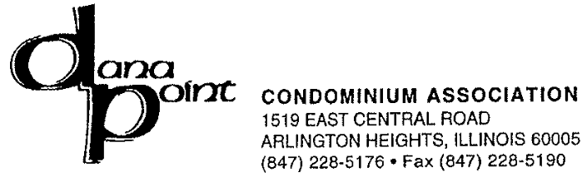

July 24, 2013

To: 1505 E. Central Rd. – All Units

Re: Water Shut - Off

Dear Residents,

On Tuesday, July 30, 2013 from 10:00 AM until 3:00 PM, maintenance will be shutting off the water in the building for plumbing repairs.

It is important that you do not use the water in your unit while the work is being performed as it prolongs the time of repairs.

Should you have any problem after the water is turned back on, let the water run in your unit for about 5-10 minutes.

If you have any questions or concerns, please call the Management Office 847-228-5176.

We apologize for any inconvenience this may cause.

Sincerely,

.The Dana Point Management Office

